Appendix

Black River State Park Welfare Analysis

While the costs and the sources of funding for the State Park were the main focus of the fiscal note detailed above, there are other potential benefits that must be considered when determining whether it is sensible to proceed with this project. The following welfare analysis goes into detail regarding the utility visitors gain by having access to this state park, and the ideal levels of visitation to maximize said utility. Potential sources of direct revenue for the government will also be discussed, as well as any spillover effects that could have a significant impact on the surrounding economy/environment, that may not be directly measurable.
To estimate a monetary value for the utility of creating a new state park, the willingness to pay for the state park (assuming no entrance fee) was derived using travel cost. This travel cost was calculated by including travel time and mileage from each North Carolina county to the Black River location, resulting in an estimate for both the opportunity cost of time associated with visiting the park and the direct travel costs. To calculate this travel cost, we added the time cost (median North Carolina hourly wage of ~ $25, multiplied by an assumed time fraction of 0.4) and the mileage cost (miles to the State Park multiplied by the 2020 IRS mileage rate) for each county to the Black River State Park.
Mayo River State Park serves as the reference park for many of the estimates, as it is similar in characteristics. Using the annual visitation for Mayo River State Park (165000 visitors), an estimate for visitors by acreage was determined by dividing these total visitors by the size of the park (2778 acres). This was then multiplied by the estimated acreage for the Black River State Park (3400 acres), to get an estimated annual visitor count of ~ 201,943. This determined estimate was then allocated among the different North Carolina counties, placing a higher preference for counties that are closer/larger (lower travel costs). A Binomial Generalized Regression Model was then used to calculate an estimate for the likelihood of visiting when travel cost is 0 (the constant alpha) and the likelihood of visiting as travel cost increases (beta). The results of this model indicate that even with a travel cost of 0, there is no guarantee of visitation. Alongside this, it can be seen that with a 1 unit increase in travel cost, the log-odds of a visit decreases by 0.0188.

Generalized Linear Model Regression Results
==============================================================================
Dep. Variable: ['visits', 'non_visits'] No. Observations: 100
Model: GLM Df Residuals: 98
Model Family: Binomial Df Model: 1
Link Function: Logit Scale: 1.0000
Method: IRLS Log-Likelihood: -17697.
Date: Mon, 30 Mar 2026 Deviance: 34554.
Time: 15:58:33 Pearson chi2: 4.16e+04
No. Iterations: 8 Pseudo R-squ. (CS): 1.000
Covariance Type: nonrobust
==============================================================================
coef std err z P>|z| [0.025 0.975]
-------------------------------------------------------------------------------
const -2.2040 0.004 -494.667 0.000 -2.213 -2.195
travel_cost -0.0189 5.27e-05 -357.993 0.000 -0.019 -0.019
==============================================================================

These estimates were then used in the following model to calculate the compensating variation (the monetary value required to compensate visitors for lost utility, if for example the park were to close), or the willingness to pay, for visitors to the state park by county. This was then aggregated to get the total WTP across all counties, which was then divided by the total state population to find an average per-capita WTP for the state of North Carolina (which includes non-visitors).
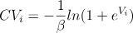
This was used to create the following visualization, showing the supply (or marginal cost, calculated from the estimates in the fiscal note) and the demand (or WTP as it changes with an increase in visitors), as well as the equilibrium quantity of visitors where the marginal WTP is equal to the marginal cost. Consumer surplus is also shown, alongside the Net Social Welfare gain from the creation of the State Park. The maximum WTP, or the choke price, is ~$39, representing the maximum amount a visitor would “pay” to retain the benefits received from having access to the park. The net social welfare of ~ $3,235,581 is positive and represents the total net benefit to society gained by having access to this state park, or in other words the economic value of the state park. The consumer surplus represents the benefit consumers (visitors) receive above the marginal cost.
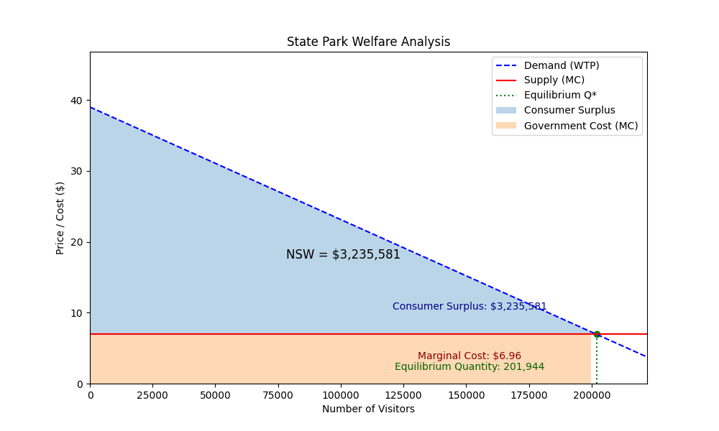
If the state park were to implement a $5 entrance fee to the park, these values change. Net social welfare decreases from $3,235,581 to $3,211,079 due to a deadweight loss of ~ $24,502 from the decrease in visitors. The lost surplus caused by the fee is mostly wealth being transferred to government revenue, with the remainder constituting the deadweight loss. The consumer surplus decreases because fewer visitors are willing to pay a $5 fee, which can be seen by the equilibrium quantity of 184,371 (versus the 201,944 before the fee). The marginal cost remains unchanged because it is in reference to the costs the producer (the government) pays per visitor, and the fee does not affect this. By implementing a $5 fee, the government can generate nearly $1 million annually, while still maintaining a positive overall net social welfare value.
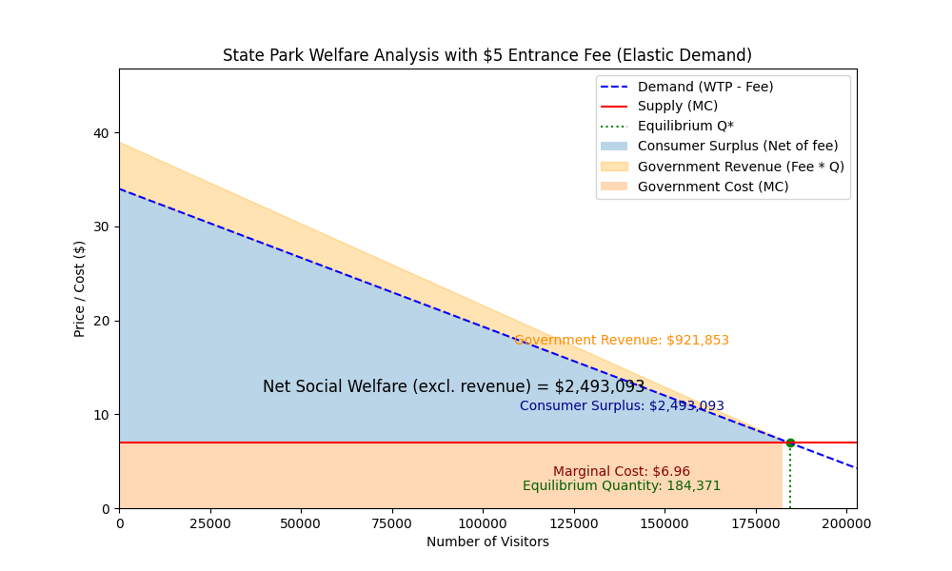
As well as the measurable utility benefits provided by the creation of the state park, there are likely to be additional spillover effects that will affect both the local economy and environment. The feasibility study of the Black River location found that there was a large amount of natural resources (flower/fauna) in the area that are of statewide importance, emphasizing the importance of establishing a protected state park location. As well as the potential environmental spillover effects, the local economies of the surrounding areas are likely to see an increase in activity with the addition of a state park. Tourism will likely rise, meaning more consumers in the surrounding counties (Sampson, Bladen, and Pender counties). Local housing markets may rise, as studies have found that close proximity to parks, greenways, or recreational areas can raise home values from 8-20%.
Alongside an entrance fee, there are various offerings the state park can consider to add potential direct revenue streams. The following table provides some examples of these offerings, and a rough estimate of annual revenue they could bring in:

Product | Estimated Units | Revenue
Camping Fees | ~11,526 | $230,530
Concessions | ~8,413 | $42,065
$5 Entrance Fee | ~184,371 | $921,853

These estimates were determined by finding the average revenue by category for North Carolina State Parks (total revenue for each category divided by the total number of parks). This was then used to determine the estimated units sold assuming an average constant cost for the offerings. Camping fees were assumed to be $20 and concessions assumed to be an average of $5. Other products may be offered depending on the park amenities, such as boat launch permits, building rentals, gift shops, etc.
There are various limitations to consider with these estimated values. First, these values are only calculated for the population of North Carolina. While state parks typically attract local (in state residents), it is almost certain that there would be difficult to track out of state visitors. Due to a lack of available data, estimates had to be made using whatever data was available. For instance, visitor data from the Mayo River State Park was used to obtain an estimate for potential visitors to the new Black River State Park. The estimates for WTP also do not take into account other surrounding parks, and if an entrance fee of $5 were to be implemented, we would assume the demand for the surrounding parks would increase, with the demand for the Black River Park decreasing by more than what is shown in the graph. The cost to travel estimates assumed a constant rate of travel, a “best-guess” mileage rate, and general distance of county coordinates to the estimated park coordinates. Expanding on these estimates by collecting real data would allow for more accurate estimates for willingness to pay and social welfare, and these limitations must be kept in mind when analyzing the results of this welfare analysis.
The societal benefits greatly outweigh the costs of the project, and the park would provide additional sources of government revenue through the form of entrance fees, concessions, camping fees, community building rentals, and more. Furthermore, spillover effects could have significant benefits on both the local environment as well as the economies in the surrounding counties due to an increase in tourism. This analysis relies heavily on rough estimates for many of the values due to a lack of data, so further data collection and analysis would be recommended to obtain more accurate values. Due to the state park providing a positive net social welfare as found in this welfare analysis, it is recommended that the project be approved.

References
Hall, Katie. “Phillips to Serve as Superintendent at Mayo River State Park.” NC State Parks, 16 Oct. 2020, www.ncparks.gov/state-parks/mayo-river-state-park/news/new-superintendent-phillips.
“Spreadsheet List of All Counties in North Carolina.Csv: Spreadsheet Download.” Gigasheet, www.gigasheet.com/sample-data/spreadsheet-list-of-all-counties-in-north-carolinacsv. Accessed 1 Apr. 2026.
“Resident Population in North Carolina.” FRED, 3 Mar. 2026, fred.stlouisfed.org/series/NCPOP.
Bonifacio, Kris. “State Parks System Grew in Visitation, Size in 2023.” NC State Parks, 25 Jan. 2024, www.ncparks.gov/about/news/visitation-systemsize-2023.
“NCCCC NC County Data.” - NC OSBM, 12 Nov. 2018, linc.osbm.nc.gov/explore/dataset/ncccc-nc-county-data/table/?flg=en-us&utm&disjunctive.area_name&disjunctive.variable.
“Black River (North Carolina).” GeoHack, geohack.toolforge.org/geohack.php?pagename=Black_River_%28North_Carolina%29&params=34_19_55_N_078_01_57_W_type%3Ariver. Accessed 1 Apr. 2026.
Curry, Sarah, and Catherine Konieczny. “State Park System Could Pay Its Own Way.” Carolina Journal, 7 May 2015, www.carolinajournal.com/opinion/state-park-system-could-pay-its-own-way/.
“An Examination of the Economic Impacts of Operations and Capital Spending.” The Economic Impact of Parks, NRPA National Recreation and Park Association, www.nrpa.org/siteassets/research/economic-impact-study-summary-2020.pdf. Accessed 1 Apr. 2026.
“Economic Benefits of Parks.” Economic Benefits of Parks : WeConservePA Library, library.weconservepa.org/guides/98-economic-benefits-of-parks. Accessed 1 Apr. 2026.
Siikamäki, Juha. “State Parks: Assessing Their Benefits.” Resources for the Future, 12 Feb. 2012, www.resources.org/archives/state-parks-assessing-their-benefits/.
Wood, Melanie. “Green Gold: How Parks Enhance Property Value and Attract Homebuyers.” Keystone Closing Services, 23 Sept. 2025, www.keystoneclosing.com/blog/where-community-grows/.
“Mayo River State Park (North Carolina).” Wikipedia, Wikimedia Foundation, 24 Feb. 2026, en.wikipedia.org/wiki/Mayo_River_State_Park_(North_Carolina).
“FEASIBILITY STUDY OF ESTABLISHING A STATE PARK ALONG THE BLACK RIVER IN SAMPSON, BLADEN AND PENDER COUNTIES.” Black River Feasibility Study, North Carolina Division of Parks and Recreation, Feb. 2018, webservices.ncleg.gov/ViewDocSiteFile/28207.
“Statistical Report of State Park Operations: 2020-2021.” Annual Information Exchange for the Period of July 1, 2020 through June 30, 2021, National Association of State Park Directors, July 2023, www.emnrd.nm.gov/spd/wp-content/uploads/sites/7/NASPD-AIX-2020-21-Final-Data-Report-released-072412023-rev.pdf.
Del Rossi, Gemma, et al. “The Economic Value of State Parks: Revealed Preference Estimates Using Cell Phone Data.” AgEcon Search, 17 May 2023.

